Lab Activity: Exploring Eddy Covariance Method

BIO16: Ecology

Fall 2020

Project Overview

Flux measurement allows ecologists to explore the exchange of important measurements such as heat, water, CO2, methane and other trace gasses across time. The Eddy Covariance (EC) method is one of the most direct and defensible ways of measuring such fluxes, and is an important tool towards understanding the water and carbon balance of ecosystems. EC measurements are made using a flux tower that has instruments for measuring gas concentrations, wind speed and direction, and often a whole suite of meteorological measurements like air temperature, barometric pressure, relative humidity, photosynthetically active radiation (i.e., light), and soil moisture and temperature. There are networks of flux towers across the globe that are used to inform and validate earth system models used to predict future greenhouse gas concentrations. 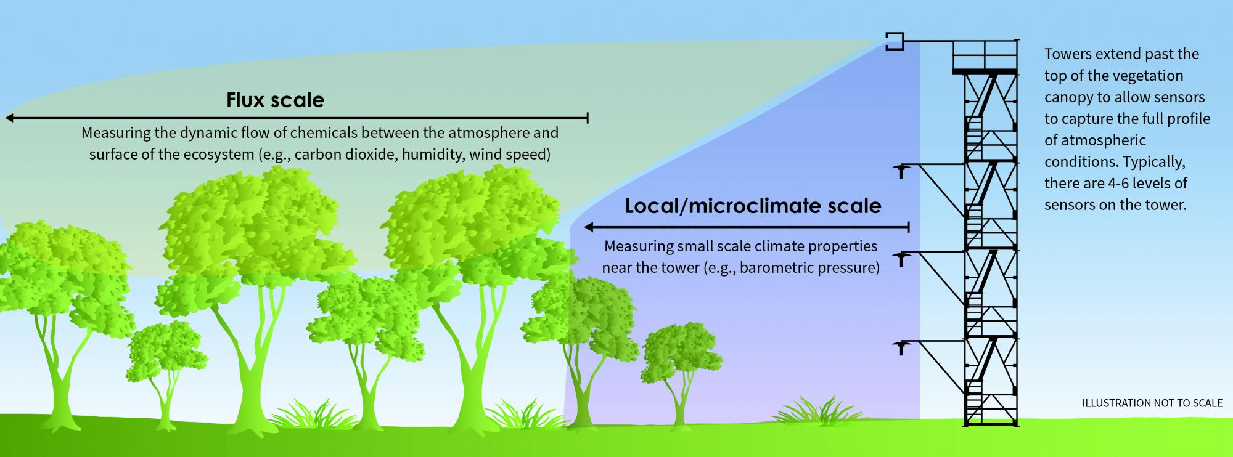

Figure 1. Schematic of flux tower measurements as part of the eddy covariance method (Source: <https://www.neonscience.org/data-collection/flux-tower-measurements>)

The purpose of this lab therefore is to introduce you to the basics of EC, to explore raw measurement data to observe patterns of eddies across seasons and time of day, and to use relationships between ecosystem carbon fluxes and meteorological variables to estimate the annual carbon balance of an ecosystem.

Learning Objectives

By completing this lab, you will:

* Explore and observe patterns from raw eddy covariance data and implications towards net ecosystem exchange (NEE)
* Visualize and understand differences between seasons (summer vs winter) and time of day (night vs day)
* Discover important meteorological and phenological properties that contribute towards overall ecosystem NEE
* Use eddy covariance data to estimate an annual carbon budget

Instructions with Incorporated Assignment Questions and Tasks (in bold)

We will be using an interactive data exploration tool developed by the DIFUSE team at Dartmouth (<https://difuse-dartmouth.shinyapps.io/DIFUSEEddyCovariance/>). For each section of the problem set below, explore the corresponding graph on the website, answer questions and take screenshots to illustrate your responses where relevant.

Part 1 Raw Data Exploration: What is raw EC data and what can it tell you?

In this section, we have raw eddy covariance data from a flux tower at the [Silas Little Experimental Forest](https://www.nrs.fs.fed.us/ef/locations/nj/silas-little/). We have data sets from both summer and winter, with 10Hz measurements of air temperature, CO2, water vapor and 3D-wind speed. Each data set available on the website will be one day (24 hours) of measurements, averaged within each second.

1. On the “Raw Data Loading Tab”, familiarize yourself with the types of data collected. And select a data set to load. Note that a positive vertical wind speed (*w*) indicates an eddy traveling up and leaving the ecosystem.
2. Go to the “Histogram” Tab. Use the tool to explore the distributions of the raw data for a winter or summer day or both at once to answer the following questions:
3. **How does the wind direction differ in winter versus summer?**
4. **How do the CO2 concentrations measured differ for a winter versus a summer day? What ecosystem processes can explain this difference?**
5. Go to the “Bivariate Plots” tab. Here is where you will be able to look at the relationship between CO2 concentrations and wind speed. Before you do, come up with some hypotheses about what you expect to see.
6. **What do you expect will happen to the CO2 concentration when the wind vertical wind speed is positive (an eddy traveling out of the ecosystem) during the day in summer? Why?**
7. **Would you expect this pattern to change at night and why?**
8. **How do you expect the CO2 concentration will change with a negative vertical wind speed in the winter? Would you expect this pattern to differ between night and day? Why?**
9. Explore the graphs that test whether your expectations were correct. Select Vertical Wind Speed for your Y axis and CO2 concentration for your X axis and load bivariate plot by time. Not all times of day will show the relationship as there will be times with no eddies or a very low flux. You can use the slider to explore times of day and can choose to look at the Summer or Winter Day. **Use captioned screenshots to show the graphs that support your hypotheses for question 3a, 3b, and 3c (or show that you were wrong!).**
10. Go to the “Observing Variable across Time” tab to search for instances of eddies. You can select both vertical wind speed and CO2 to plot at the same time and choose a winter or summer day. Once the graph is loaded, you can zoom in on different parts of the graphs or use the slider to focus on a certain time of day. Double click to go back to the view of the whole graph.
11. Find one or more instances of eddies demonstrating one of the covariance scenarios during summer. **Use a captioned screenshot to share one here.**
12. **Was it harder to find examples of the eddies at certain times of day? Why would this be so?**

Part 2 Processed Data Exploration: Environmental relationships with NEE and calculating the ecosystem carbon balance

In this section, we explore eddy covariance data from the same site. This data has passed through the data pipeline to calculate the flux (µmolCO2 m-2 s-1) for 30-minute intervals. These data are for the entire year of 2018 and contain more variables than the raw data above. Familiarize yourself with the types of data collected. *Please note* that a negative NEE indicates the ecosystem is taking up carbon (is a carbon sink) while a positive NEE indicates that the ecosystem is losing carbon (is a carbon source). Use the tool to explore the processed data and answer the following questions.

1. On the “Observing Variables across Time” tab, observe how the patterns in NEE change with Julian Day (the day of year from 1 to 365). **Make a series of predictions as to what variables explain the variation in NEE throughout the year.** You can explore how other variables change over the year to inform your predictions.
2. During the year these data were collected (2018), the flux was able to be calculated only 43% of the time, so 57% of the time needs to be gap-filled, which you will do by building a regression model.
3. On the “Bivariate Plots” of the “Regression Model” tab, you can explore your predictions by looking at bivariate plots showing the relationship between NEE and potential predictor variables (e.g., Julian day, Photosynthetically active radiation, Air temperature, etc.) If the relationship between the variables does not look linear, you can apply a polynomial transformation to the predictor to see if that improves the fit of the data. You can also add an interaction where the relationship between NEE and the predictor differs by the levels of another variable. **What are your predictor variables? Share the plots of the predictors that you think best explain the variation in NEE using captioned screenshots.**
4. Once you have explored the data, you can build a multiple linear regression (multiple because there is more than one predictor and linear because it assumes the relationships between your dependent variable and independent variables are linear) by going to the “Regression Builder” tab, choosing the variables (transformed and with interactions if need be) like you did with the graphs and then scrolling down and clicking “Add term to model”. You are able to add as many terms as you think are needed for describing the NEE data, but strive to simplify the model and use 2-4 of the most informative terms. Once you are done, click “Fit Model”.
5. Go to the “Model Evaluation” tab, which will show you how well your model fits the data. You want the graphs to show a positive, linear relationship between your data (the Truth) and the model’s estimate. The R-squared value is an estimate of how much variability in the NEE data was explained by your model. Higher is better. Aim for at least an R-squared of 0.5. If you want to improve your model, you can click “Reset Model” and try again.
6. **Once you have a model you are happy with… what are the terms you included? Include a captioned screenshot of the Fitted values versus True graph.**
7. Now you can gap fill and estimate the annual carbon balance of the ecosystem. Click “Gapfill missing NEE values”, which will use the model you just made to gapfill the data and go to the “Gapfilling” tab.
8. **What is the total NEE of this forest ecosystem? Was it a source or sink of carbon in 2018?**

1. **How does the source and sink strength for carbon change seasonally?**